**Question 2 – part1**

|  |  |  |  |  |  |  |  |  |  |  |  |
| --- | --- | --- | --- | --- | --- | --- | --- | --- | --- | --- | --- |
| **Time** | **Figs** | **Total of 4** | **Total of 8** | **Moving Average (Trend)** | **Seasonal Variation** | **Q1** | **Q2** | **Q3** | **Q4** | **Adjusted Seasonal Variation** | **OurDes Figures** |
| **Q4_December** | 10749 |  |  |  |  |  |  |  |  | 175,301 | 10573,699 |
|  |  |  |  |  |  |  |  |  |  |  |  |
| **Q1_March** | 10854 |  |  |  |  |  |  |  |  | 7,971 | 10846,029 |
|  |  | 42140 |  |  |  |  |  |  |  |  |  |
| **Q2_June** | 10570 |  | 84338 | 10542,250 | 27,750 |  | 27,750 |  |  | 171,801 | 10398,199 |
|  |  | 42198 |  |  |  |  |  |  |  |  |  |
| **Q3_September** | 9967 |  | 83942 | 10492,750 | -525,750 |  |  | -525,750 |  | -355,074 | 10322,074 |
|  |  | 41744 |  |  |  |  |  |  |  |  |  |
| **Q4_December** | 10807 |  | 83382 | 10422,750 | 384,250 |  |  |  | 384,250 | 175,301 | 10631,699 |
|  |  | 41638 |  |  |  |  |  |  |  |  |  |
| **Q1_March** | 10400 |  | 83746 | 10468,250 | -68,250 | -68,250 |  |  |  | 7,971 | 10392,029 |
|  |  | 42108 |  |  |  |  |  |  |  |  |  |
| **Q2_June** | 10464 |  | 84433 | 10554,125 | -90,125 |  | -90,125 |  |  | 171,801 | 10292,199 |
|  |  | 42325 |  |  |  |  |  |  |  |  |  |
| **Q3_September** | 10437 |  | 84442 | 10555,250 | -118,250 |  |  | -118,250 |  | -355,074 | 10792,074 |
|  |  | 42117 |  |  |  |  |  |  |  |  |  |
| **Q4_December** | 11024 |  | 84320 | 10540,000 | 484,000 |  |  |  | 484,000 | 175,301 | 10848,699 |
|  |  | 42203 |  |  |  |  |  |  |  |  |  |
| **Q1_March** | 10192 |  | 83956 | 10494,500 | -302,500 | -302,500 |  |  |  | 7,971 | 10184,029 |
|  |  | 41753 |  |  |  |  |  |  |  |  |  |
| **Q2_June** | 10550 |  | 83521 | 10440,125 | 109,875 |  | 109,875 |  |  | 171,801 | 10378,199 |
|  |  | 41768 |  |  |  |  |  |  |  |  |  |
| **Q3_September** | 9987 |  | 84190 | 10523,750 | -536,750 |  |  | -536,750 |  | -355,074 | 10342,074 |
|  |  | 42422 |  |  |  |  |  |  |  |  |  |
| **Q4_December** | 11039 |  | 85226 | 10653,250 | 385,750 |  |  |  | 385,750 | 175,301 | 10863,699 |
|  |  | 42804 |  |  |  |  |  |  |  |  |  |
| **Q1_March** | 10846 |  | 85974 | 10746,750 | 99,250 | 99,250 |  |  |  | 7,971 | 10838,029 |
|  |  | 43170 |  |  |  |  |  |  |  |  |  |
| **Q2_June** | 10932 |  | 86158 | 10769,750 | 162,250 |  | 162,250 |  |  | 171,801 | 10760,199 |
|  |  | 42988 |  |  |  |  |  |  |  |  |  |
| **Q3_September** | 10353 |  | 85860 | 10732,500 | -379,500 |  |  | -379,500 |  | -355,074 | 10708,074 |
|  |  | 42872 |  |  |  |  |  |  |  |  |  |
| **Q4_December** | 10857 |  | 85388 | 10673,500 | 183,500 |  |  |  | 183,500 | 175,301 | 10681,699 |
|  |  | 42516 |  |  |  |  |  |  |  |  |  |
| **Q1_March** | 10730 |  | 84573 | 10571,625 | 158,375 | 158,375 |  |  |  | 7,971 | 10722,029 |
|  |  | 42057 |  |  |  |  |  |  |  |  |  |
| **Q2_June** | 10576 |  | 83418 | 10427,250 | 148,750 |  | 148,750 |  |  | 171,801 | 10404,199 |
|  |  | 41361 |  |  |  |  |  |  |  |  |  |
| **Q3_September** | 9894 |  | 81771 | 10221,375 | -327,375 |  |  | -327,375 |  | -355,074 | 10249,074 |
|  |  | 40410 |  |  |  |  |  |  |  |  |  |
| **Q4_December** | 10161 |  | 80290 | 10036,250 | 124,750 |  |  |  | 124,750 | 175,301 | 9985,699 |
|  |  | 39880 |  |  |  |  |  |  |  |  |  |
| **Q1_March** | 9779 |  | 79020 | 9877,500 | -98,500 | -98,500 |  |  |  | 7,971 | 9771,029 |
|  |  | 39140 |  |  |  |  |  |  |  |  |  |
| **Q2_June** | 10046 |  | 77399 | 9674,875 | 371,125 |  | 371,125 |  |  | 171,801 | 9874,199 |
|  |  | 38259 |  |  |  |  |  |  |  |  |  |
| **Q3_September** | 9154 |  | 75957 | 9494,625 | -340,625 |  |  | -340,625 |  | -355,074 | 9509,074 |
|  |  | 37698 |  |  |  |  |  |  |  |  |  |
| **Q4_December** | 9280 |  | 74448 | 9306.000 | -26,000 |  |  |  | -26,000 | 175,301 | 9104,699 |
|  |  | 36750 |  |  |  |  |  |  |  |  |  |
| **Q1_March** | 9218 |  | 72437 | 9054,625 | 163,375 | 163,375 |  |  |  | 7,971 | 9210,029 |
|  |  | 35687 |  |  |  |  |  |  |  |  |  |
| **Q2_June** | 9098 |  | 70320 | 8790,000 | 308,000 |  | 308,000 |  |  | 171,801 | 8926,199 |
|  |  | 34633 |  |  |  |  |  |  |  |  |  |
| **Q3_September** | 8091 |  | 67892 | 8486,500 | -395,500 |  |  | -395,500 |  | -355,074 | 8446,074 |
|  |  | 33259 |  |  |  |  |  |  |  |  |  |
| **Q4_December** | 8226 |  | 65767 | 8220,875 | 5,125 |  |  |  | 5,125 | 175,301 | 8050,699 |
|  |  | 32508 |  |  |  |  |  |  |  |  |  |
| **Q1_March** | 7844 |  | 64383 | 8047,875 | -203,875 | -203,875 |  |  |  | 7,971 | 7836,029 |
|  |  | 31875 |  |  |  |  |  |  |  |  |  |
| **Q2_June** | 8347 |  | 62926 | 7865,750 | 481,250 |  | 481,250 |  |  | 171,801 | 8175,199 |
|  |  | 31051 |  |  |  |  |  |  |  |  |  |
| **Q3_September** | 7458 |  | 61855 | 7731,875 | -273,875 |  |  | -273,875 |  | -355,074 | 7813,074 |
|  |  | 30804 |  |  |  |  |  |  |  |  |  |
| **Q4_December** | 7402 |  | 60344 | 7543,000 | -141,000 |  |  |  | -141,000 | 175,301 | 7226,699 |
|  |  | 29540 |  |  |  |  |  |  |  |  |  |
| **Q1_March** | 7597 |  | 58162 | 7270,250 | 326,750 | 326,750 |  |  |  | 7,971 | 7589,029 |
|  |  | 28622 |  |  |  |  |  |  |  |  |  |
| **Q2_June** | 7083 |  | 56456 | 7057,000 | 26,000 |  | 26,000 |  |  | 171,801 | 6911,199 |
|  |  | 27834 |  |  |  |  |  |  |  |  |  |
| **Q3_September** | 6540 |  | 54353 | 6794,125 | -254,125 |  |  | -254,125 |  | -355,074 | 6895,074 |
|  |  | 26519 |  |  |  |  |  |  |  |  |  |
| **Q4_December** | 6614 |  | 52234 | 6529,250 | 84,750 |  |  |  | 84,750 | 175,301 | 6438,699 |
|  |  | 25715 |  |  |  |  |  |  |  |  |  |
| **Q1_March** | 6282 |  | 50488 | 6311,000 | -29,000 | -29,000 |  |  |  | 7,971 | 6274,029 |
|  |  | 24773 |  |  |  |  |  |  |  |  |  |
| **Q2_June** | 6279 |  | 49079 | 6134,875 | 144,125 |  | 144,125 |  |  | 171,801 | 6107,199 |
|  |  | 24306 |  |  |  |  |  |  |  |  |  |
| **Q3_September** | 5598 |  | 48208 | 6026,000 | -428,000 |  |  | -428,000 |  | -355,074 | 5953,074 |
|  |  | 23902 |  |  |  |  |  |  |  |  |  |
| **Q4_December** | 6147 |  | 47265 | 5908,125 | 238,875 |  |  |  | 238,875 | 175,301 | 5971,699 |
|  |  | 23363 |  |  |  |  |  |  |  |  |  |
| **Q1_March** | 5878 |  |  |  |  |  |  |  |  | 7,971 | 5870,029 |
|  |  |  |  |  |  |  |  |  |  |  |  |
| **Q2_June** | 5740 |  |  |  |  |  |  |  |  | 171,801 | 5568,199 |
|  |  |  |  |  |  |  |  |  |  |  |  |
|  |  |  |  |  | **Total** | 45,625 | 1689,000 | -3579,750 | 1724,000 |  |  |
|  |  |  |  |  | **Seasonal Variation** | 5,069 | 168,900 | -357,975 | 172,400 | -11,606 |  |
|  |  |  |  |  | **Adjusted seasonal variation** | 7,971 | 171,801 | -355,074 | 175,301 | 0,000 |  |

Question 2 –part2

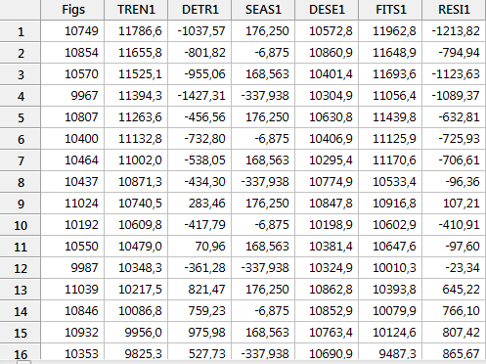

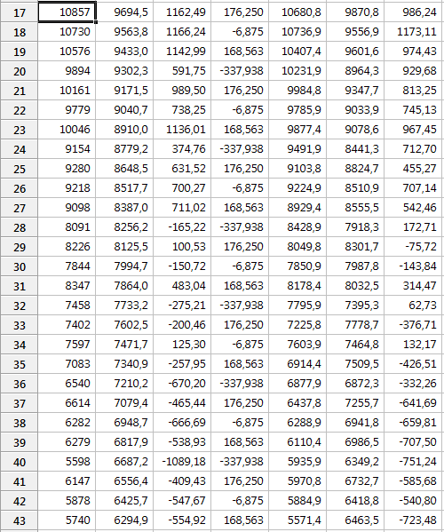







The autocorrelation plot for the residuals is:



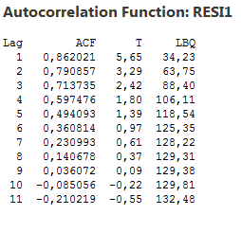

The partial autocorrelation plot is:



